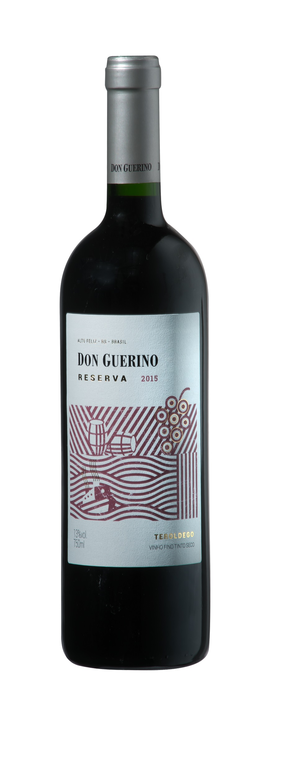

DON GUERINO RESERVA TEROLDEGO
TASTING NOTE

- 100% Teroldego
- 13% Abv.
- Rests in both French & US oak for 6 months, then 6 months in bottle before release
- Produced from vines aged approx. 12 years
- Bright; very deep inky-purple colour
- High concentration of warm ripe dark brambly fruits on nose, overlaid with lighter raspberry/redcurrant notes
- Also, an herby character to nose, some leathery notes and chocolate
- Black cherry fruit on palate, with traces of vanilla, liquorice and even smokiness
- Dry with rich palate, medium bodied, some earthy notes
- Tannins quite soft and restrained
- Highish acidity, will make this an excellent food wine
- Long finish, slightly bitter or sour cherry
- Will drink well for 1-2 years
SERVING SUGGESTION

→ Serve at warmish room temperature, best partnered with roast lamb or pork
ADDITIONAL NOTES

- Privately owned family winery, started in business for themselves in 2000
- (Sr. Guerino) Motter family first arrived in Brazil in 1879
- Based in Alto Feliz, 25km southeast of Bento Gonçalves
- Winery located at approx. 500m in the Serra Gaúcha hills
- 55-hectare vineyard on sunny, well-ventilated north-facing slopes
- Current winemaker Bruno Motter studied in Mendoza, Argentina
Don Guerino has an impressive portfolio of red, white and sparkling wines, all (bar one) produced from grapes grown in their own vineyard (nb. Ancellota)

