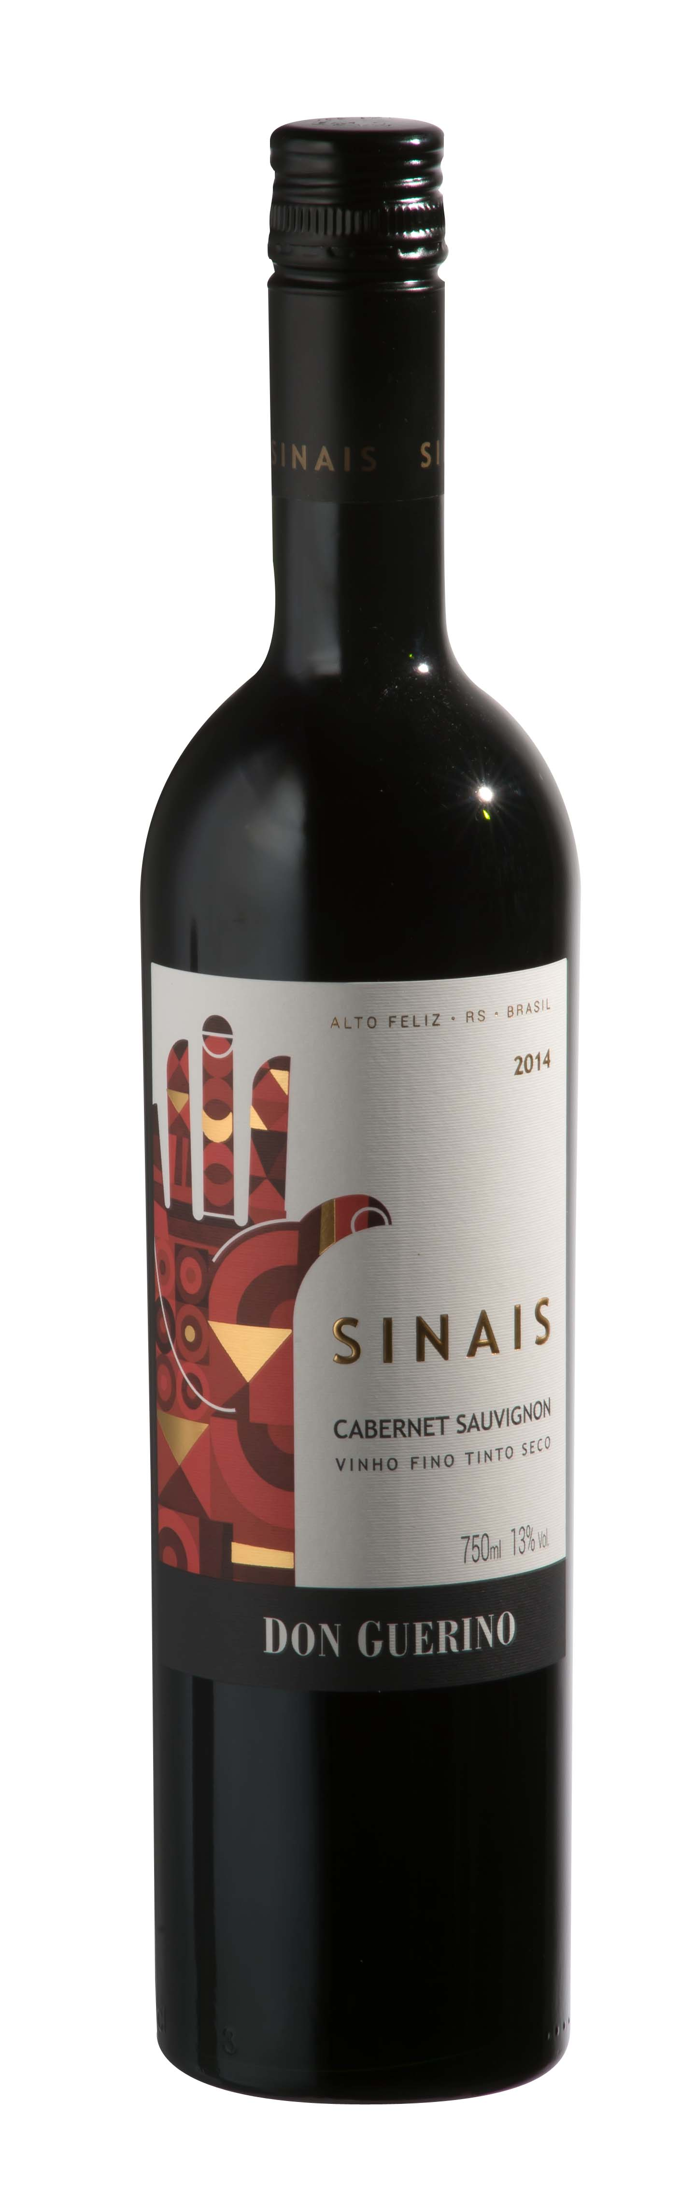
DON GUERINO SINAIS CABERNET SAUVIGNON

TASTING NOTE

- 100% Cabernet Sauvignon
- 13% Abv.
- Unoaked
- Deep ruby colour
- Concentration of fresh black fruits on nose, hints of black pepper and green capsicum
- Ripe dark blackcurrant and plum on palate, youthful fruit tannins
- Well rounded and smooth, moderate acidity
- Dry overall but pleasant natural sweetness from fruit
- Enjoy while wine is fresh and young, within 2-3 years of vintage
- Elegant, slim bottle, part of wider ‘Sinais’ (‘Signs’) range
- Cork closure (not screwcap as in image above)

SERVING SUGGESTION

→Try with grilled meats, mushroom stroganoff, mild- to medium flavoured cheeses
ADDITIONAL NOTES

- Multi-award-winning privately-owned family winery
- Own wines produced since 2000, but winery built only in 2007-super modern!
- Sr. Guerino Motter first arrived in Brazil in 1879
- Based in Alto Feliz, 25km southeast of Bento Gonçalves
- Winery located at approx. 500m in the Serra Gaúcha mountains
- 55-hectare vineyard on sunny, well-ventilated north-facing slopes
- Iron-rich red soil gives colour and body to the range of wines
- Winemaker Bruno Motter (age 30) studied in Mendoza, Argentina
- Reputedly Brazil’s largest producer of Malbec
- Don Guerino has an impressive portfolio of red, white and sparkling wines, all (bar one) produced from grapes grown in their own vineyard
Sinais is winery’s second range, all unoaked, intended to be consumed young

