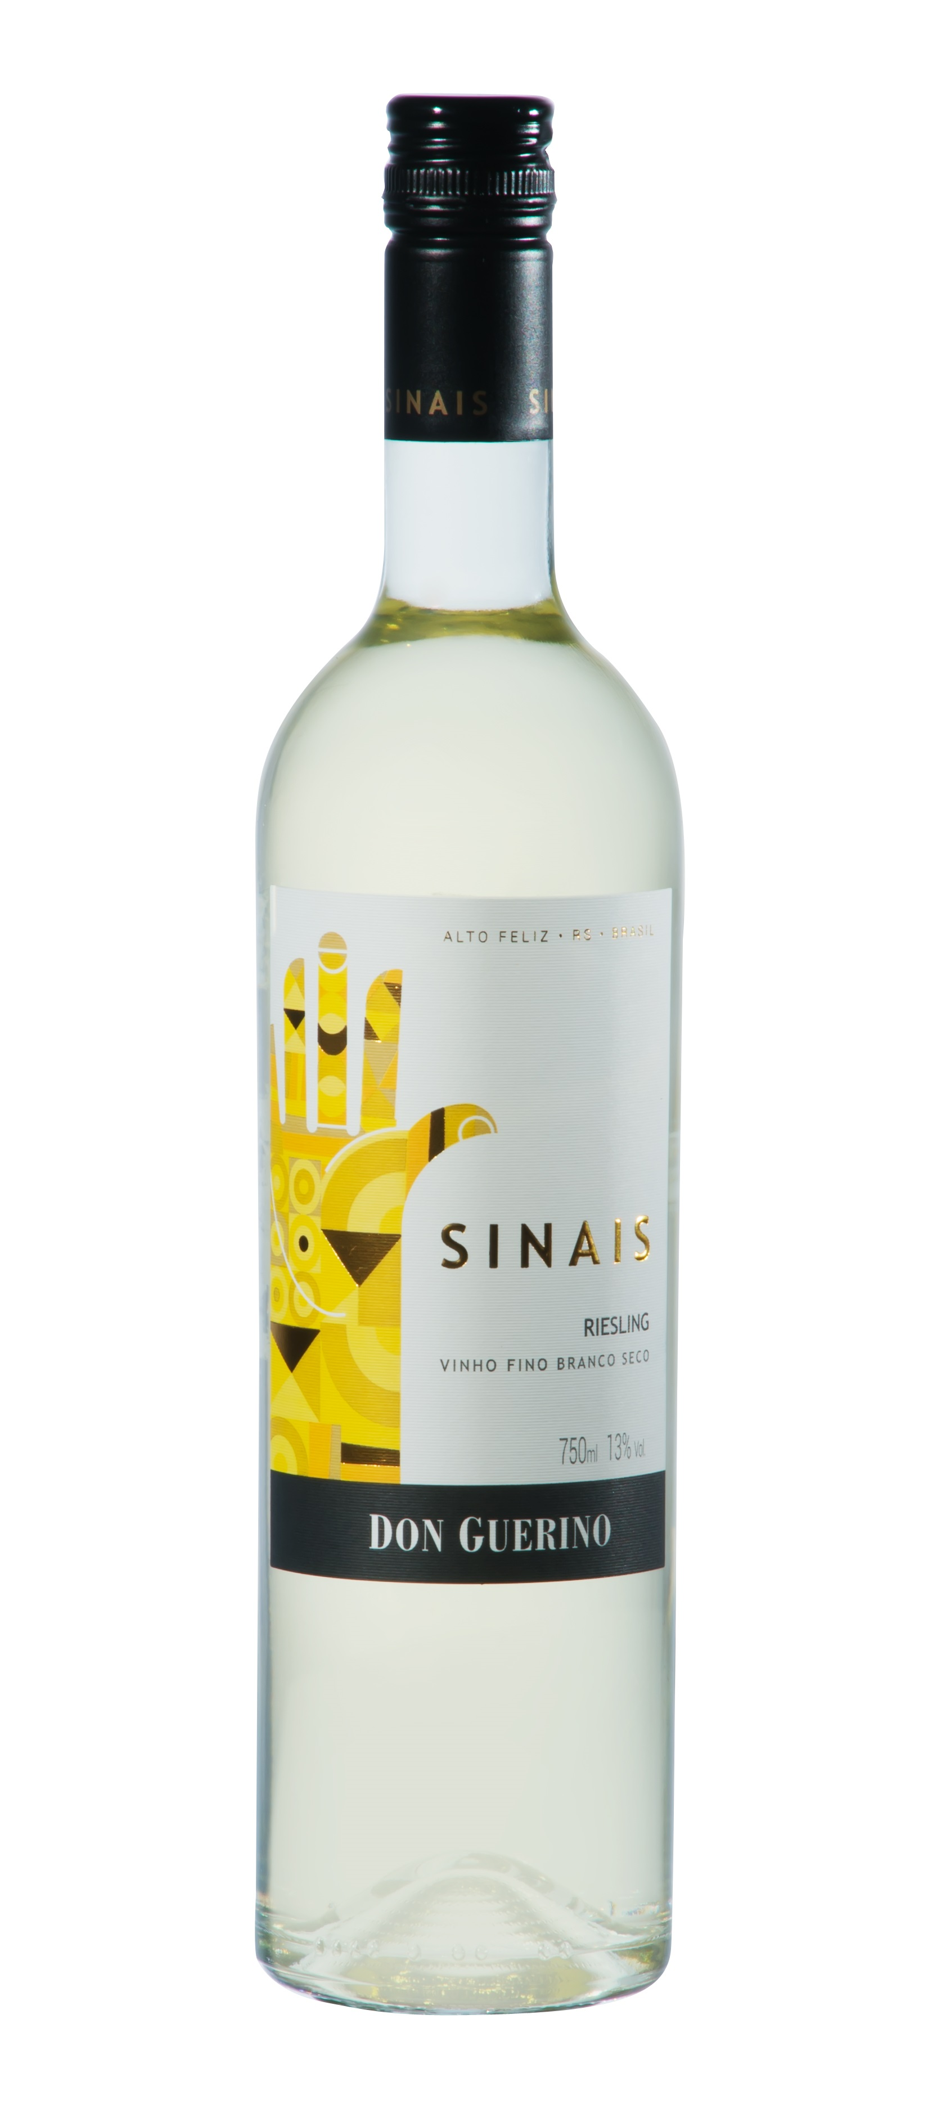

DON GUERINO SINAIS RIESLING
TASTING NOTE

- 100% Itálico Riesling (or ‘Welschriesling’, unrelated to Rhein Riesling!)
- Grapes bought in from local vineyard(s?), on clay soil, approx. altitude 700m
- 13% Abv.
- Stays for 4 months on lees prior to bottling
- Pale yellow with green reflexes
- Aromatic on nose - tropical notes of melon, pineapple, peach and a tad floral
- Palate also shows ripe tropical fruit, especially pineapple – lacks minerality of Old World ‘Rhine’ Riesling!
- Dry, with decent level of acidity
- As with Sinais Sauvignon Blanc, just a hint of spritz on palate.
- Finish is quite long, with soft stone fruit and pineapple flavours lingering
- Drink young, within 2 years of vintage
- Elegant, slim bottle!
- Screwcap closure
SERVING SUGGESTION

→ Serve well chilled, works well on its own or with light salads, hors d’oeuvres, fish
ADDITIONAL NOTES

- Multi-award-winning privately-owned family winery
- Own wines produced since 2000, but winery built only in 2007-super modern!
- Motter family first arrived in Brazil in 1879
- Based in Alto Feliz, 25km southeast of Bento Gonçalves
- Winery located at approx. 500m in the Serra Gaúcha mountains
- 55-hectare vineyard on sunny, well-ventilated north-facing slopes
- Iron-rich red soil gives colour and body to the range of wines
- Winemaker Bruno Motter studied in Mendoza, Argentina
- Reputedly Brazil’s largest producer of Malbec
Don Guerino has an impressive portfolio of red, white and sparkling wines, all (bar this and one other) produced from grapes grown in their own vineyard

