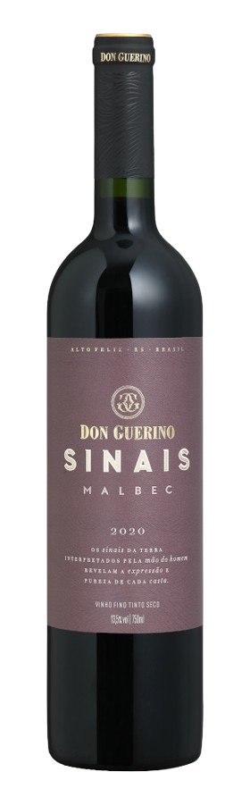
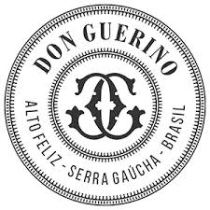
DON GUERINO SINAIS MALBEC 2022

TASTING NOTE

- 100% Malbec
- 13.5% Abv.
- Unoaked
- Ripe dark plum and blackcurrant flavours
- Elegant, slim bottle, part of wider ‘Sinais’ (‘Signs’) range
- Cork closure

SERVING SUGGESTION

- Pairing with red & white meats, pasta,
- pizza and chilli-based dishes

ADDITIONAL NOTES

- Multi-award-winning privately-owned family winery
- Own wines produced since 2000, but winery built only in 2007-super modern!
- Sr. Guerino Motter first arrived in Brazil in 1879
- Based in Alto Feliz, 25km southeast of Bento Gonçalves
- Winery located at approx. 500m in the Serra Gaúcha mountains
- 55-hectare vineyard on sunny, well-ventilated north-facing slopes
- Iron-rich red soil gives colour and body to the range of wines
- Winemaker Bruno Motter (age 30) studied in Mendoza, Argentina
- Reputedly Brazil’s largest producer of Malbec
Sinais is winery’s second range, all unoaked, intended to be consumed young

