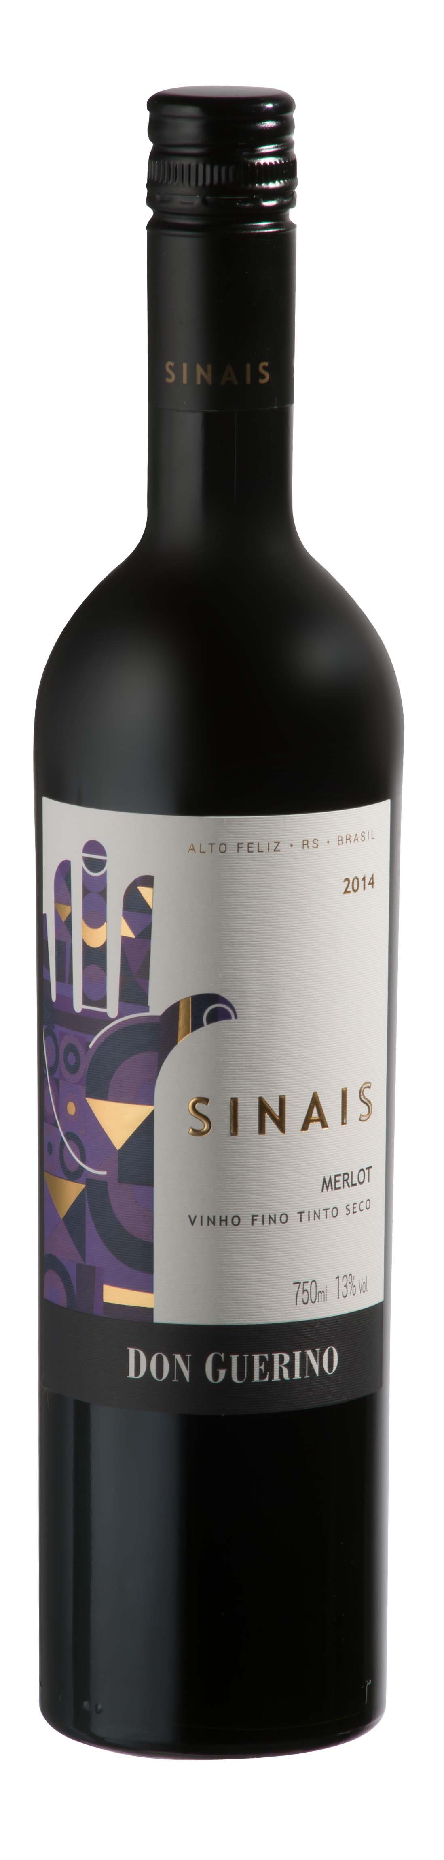

DON GUERINO SINAIS MERLOT

TASTING NOTE

- 100% Merlot
- 13% Abv.
- Unoaked
- Concentration of ripe red fruits on nose, plum and cherry dominant
- Warm ripe berry fruit continues palate
- Well rounded and smooth, moderate acidity and gentle fine tannins – all of which make the wine very accessible!
- Dry overall but pleasant natural sweetness from fruit
- Enjoy while wine is fresh and young, within 2-3 years of vintage
- Elegant, slim bottle, part of wider ‘Sinais’ (‘Signs’) range
- Cork closure (not screwcap as in image above)

SERVING SUGGESTION

→Ideal lunchtime drinking: try pairing with roast chicken and caramelised vegetables or mildly spiced red meats
ADDITIONAL NOTES

- Multi-award-winning privately-owned family winery
- Own wines produced since 2000, but winery built only in 2007-super modern!
- Motter family first arrived in Brazil in 1879
- Based in Alto Feliz, 25km southwest of Bento Gonçalves
- Winery located at approx. 500m in the Serra Gaúcha mountains
- 55-hectare vineyard on sunny, well-ventilated north-facing slopes
- Iron-rich red soil gives colour and body to the range of wines
- Winemaker Bruno Motter studied in Mendoza, Argentina
- Reputedly Brazil’s largest producer of Malbec
Don Guerino has an impressive portfolio of red, white and sparkling wines, all (bar one) produced from grapes grown in their own vineyard

