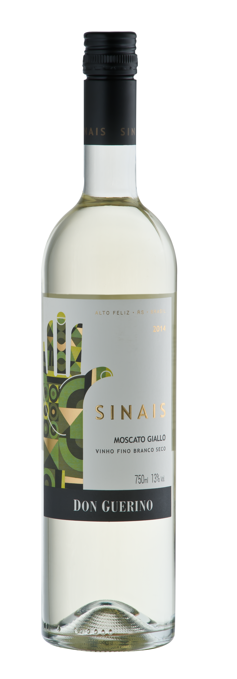

DON GUERINO SINAIS MOSCATO GIALLO

TASTING NOTE

- 100% Moscato Giallo (‘yellow Muscat’)
- 13% Abv.
- Rests for 4 months on lees prior to bottling
- Very pale green, yellow, almost water-white
- Aromatic on nose, with jasmine, passion fruit and citrus notes to the fore
- Light and cleansing palate; lemon/lime and ripe tropical fruits,
e.g papaya, apparent
- Dry and crisp, with decent level of acidity
- Finish is quite long, with citrussy grapefruit flavours lingering
- Drink young, within 1-2 years of vintage
- Elegant, slim bottle, one of 6 labels in the entry level+ Sinais (‘signs’) range
- Screwcap closure
SERVING SUGGESTION

→ Serve well chilled, works well on its own or with light salads, hors d’oeuvres, white fish dishes
ADDITIONAL NOTES

- Multi-award-winning privately-owned family winery
- Own wines produced since 2000, but winery built only in 2007, extension added late 2018 – an impressive structure, with v.high quality interior finish!
- Motter family first arrived in Brazil in 1879
- Based in Alto Feliz, 25km southeast of Bento Gonçalves
- Winery located at approx. 500m in the Serra Gaúcha mountains
- 55-hectare vineyard on sunny, well-ventilated north-facing slopes
- Iron-rich red soil gives colour and body to the range of wines
- Winemaker Bruno Motter studied in Mendoza, Argentina
- Reputedly Brazil’s largest producer of Malbec
- Don Guerino has an impressive portfolio of red, white and sparkling wines, all (bar one) produced from grapes grown in their own vineyard
2018 arguably the best vintage in living memory, certainly in last 20 yrs!

