
Guaspari Vale da Pedra Branco
A winter harvest wine produced within the Tropics in the highlands of São Paulo state, this is an unusual but elegant and superbly made three grape white blends, comprising principally Sauvignon Blanc (83%) with a dash of Chardonnay (13%) and Viognier (4%).
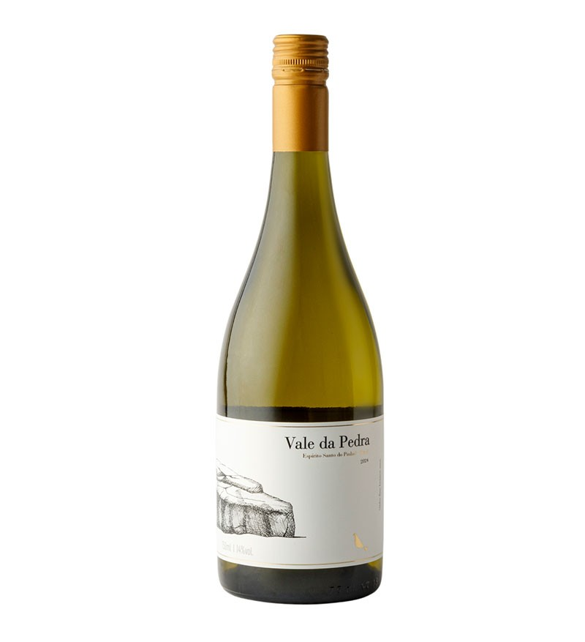
Fresh and vibrant, this is very much a ‘gastronomic’ white – see tasting note below. Very slightly floral, with grassy aromas and a beautifully textured palate, it shows a citrussy/lime freshness and tropical fruits, underpinned by a keen acidity.
The etched, artist-designed bottle label is also impressive, featuring a granite rock formation from within the superb Guaspari vineyard, which is sited on a former colonial-era coffee plantation spanning some 700 htrs.

Description
Medium-bodied and intriguingly textured, the wine shows citrus, grassiness, elderflower and even green (unripe) coffee aromas. Ripe stone fruit and other, more tropical, flavours are evident on a clean, dry palate. Acidity is appropriately high, while a lean, mineral note makes for real freshness and a long finish. Serve with cold plates, salads, seafood, white fish, chicken or turkey.
Guaspari is a young, multi award-winning winery located on the site of a colonial-era coffee plantation in the highlands of São Paulo state in southeast Brazil.
Despite the vineyard’s high altitude (900-1300m), it is usually too hot and/or wet to harvest during February or March, the months when the grape harvest would typically occur in the much more southerly Serra Gaúcha hills.
To avoid this scenario, an additional, second pruning of the vines takes place, thus delaying the harvest until the cooler and drier winter months of July/August, and allowing the grapes to ripen more slowly before reaching maturity. This 2021 vintage is therefore now 20 months old (at April 2023).

