
GUASPARI VALE PEDRA SYRAH

A superb quality, heavyweight 100% Syrah (Shiraz), with a previous vintage awarded a Silver Medal in the Decanter 2019 World Wine Awards, and made by a young winery in the highlands of São Paulo state.
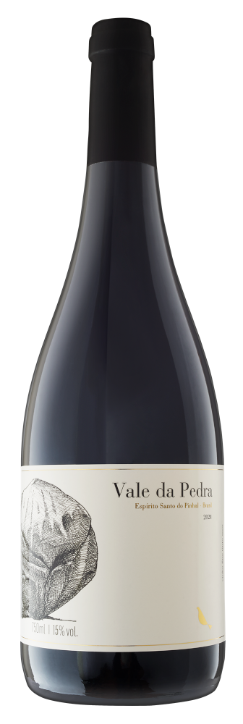
Stylistically a little reminiscent of a Northern Rhône red, it’s packed full of cloves, spice and intense dark savoury-sweet fruit. Oaky and smoky, this is a full-bodied wine with a long finish. Has potential for many years ageing. See below for our own and wine critic Tom Cannavan’s tasting notes.
Will appeal to lovers of big, ‘meaty’ reds and best enjoyed with steaks, roast beef or lamb, venison, BBQ fare and well-seasoned/spiced dishes.
Unusually, grapes are harvested in winter (end July/early August), when temperatures are cooler and the weather drier than would otherwise be the case in February/March, the usual time for the harvest to take place in far south of Brazil.
See also Guaspari’s Vista da Serra Syrah, a similar wine but aged for longer in barrel, it is more concentrated and heavier than the ‘Tinto’, and featured on the front cover of Decanter in October 2020 – scoring 95 points! Abv. 15%

Description
A deep ruby colour, on the nose it shows a spiciness typical of the varietal, together with a concentration of red fruits and a floral perfume of rosemary and dried herbs. Medium to full bodied, this is a powerful and intense wine with a lovely lingering finish. Aged in used French barriques for 8-9 months, then rested in bottle for min. 12 months prior to release.
See also:
Launching for the first time in the UK, Guaspari is a young, multi award-winning winery located on the site of an old coffee plantation in the highlands of São Paulo state.
Despite the vineyard’s high altitude (900-1300m), it is usually too hot and/or wet to pick grapes during February or March, the months when the harvest would typically occur in the more southerly Serra Gaúcha hills.
To avoid this scenario, an additional, second pruning of the vines takes place, so delaying the harvest until the cooler and drier winter months of July and August, and allowing the grapes to ripen more slowly before they reach maturity.

